South East Scotland Cancer Network
Regional Primary Care Group

Terms of Reference
2020 - 2022

Date Published 05.02.2020
Version 1.0
Author M. Paterson
Review Date February 2022

Accountable To
The SCAN Primary Care Group shall be accountable to the SCAN Regional Cancer Planning Group as detailed in the SCAN Governance Structure (Paragraph 5)

Purpose of the Group
The Group’s role is not task focussed in the same way as the SCAN Tumour Specific Groups and so a structured biennial work plan is not appropriate. However certain issues requiring action will be identified from time to time. The Chairperson will be responsible for ensuring any such work is progressed and documented appropriately.

Remit of the Group
The aims of the SCAN Regional Primary Care Reference Group are to promote:

- The highest standards of cancer care, focussing particularly on primary care aspects of the patient journey from prevention and screening, through to diagnosis, treatment and follow up and including end of life issues such as palliative care and bereavement;

- Equity of access to cancer services with care delivered locally where feasible

- The dissemination of information across the primary/secondary/tertiary care interfaces.

Group Membership

Core Membership
Current Chair: Fiona O’Brien
Designation | Name
Lead Cancer GP: NHS Borders | Maude Donkers
Lead Cancer GP: NHS D&G | Fiona O’Brien
Lead Cancer GP: NHS Fife
Lead Cancer GP: NHS Lothian | Lorna Porteous
Nursing Representation: NHS Borders
Nursing Representation: NHS D&G
Nursing Representation: NHS Fife
Nursing Representation: NHS Lothian
University of Edinburgh Representation | Christine Campbell
SCAN Network Manager | Bobby Alikhani
SCAN Patient Involvement Manager | Helen Taylor
SCAN Project Support Manager | Michael Paterson
Patient Representative

Others may be co-opted from time to time as may be required, for example: SCAN Clinical Lead. Third Sector, Referrals Advisor, Pharmacy, Social Work, and Public Health representatives.

The quorum for meetings shall be a representation from at least three out of the four Health Boards.

In Attendance
The group reserves the right to ask appropriate Board, regional and SCAN colleagues to attend their meetings as required by the agenda.

Chair
The Chair will be appointed with the explicit backing of Group members.

Tenure: The standard period of tenure will be 3 years. The Chair may serve for a second 3-year term, subject to approval by the current group and the SCAN Clinical Lead.

The responsibilities of the Chair are to ensure that:

- The requisite number of meetings are held each year;
- Meetings are accurately documented;
- Any work undertaken by the Group is progressed and documented appropriately;

Governance Structure
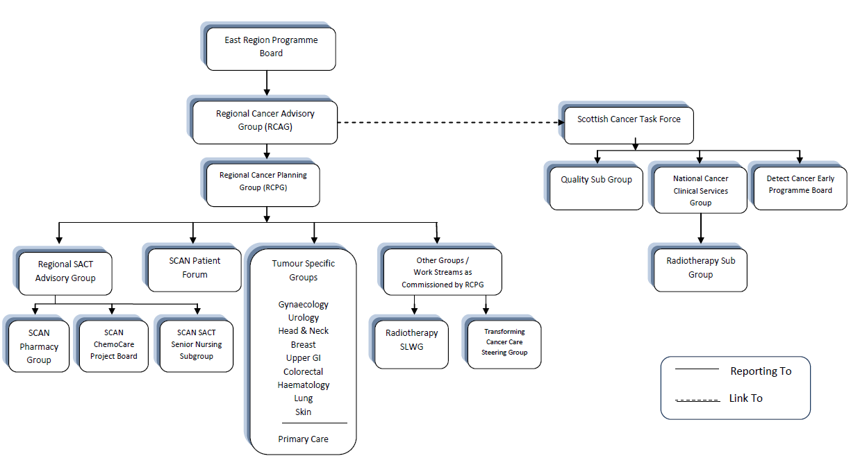

Decision Making

The quorum of this board to allow decision making is:
- Chair
- At least one representative from three of the four regional Health Boards

Frequency of Meetings
The Group will hold a minimum of three meetings per year.

An agenda and relevant papers will be sent out via email one week prior to each meeting with the administration support for the meeting provided by the SCAN Team.

Links with Other Groups
Members of the Group will be responsible for cascading information to and from colleagues. Mechanisms for this include direct communication with individual Practices and Primary Care clinicians through the Boards' Lead Cancer GPs and nurses, Board management structures, and GP sub-committees of Area Medical Committees.

Members of the Group will develop good working relationships with all the other SCAN Groups and other bodies such as the Scottish Primary Care Cancer Group, providing suitable representation on them as may be appropriate.

SCAN Primary Care Reference Group interface with SCAN Tumour Specific Groups:

- A member of the SCAN PCG (Group Lead) sits on each of the Tumour Specific Groups (TSGs) in order to provide a primary care perspective to tumour specific issues;
- Attendance at every TSG meeting is not necessary but the Group Leads must check all Minutes and the Agenda to identify issues that require a primary care input;
- All SCAN PCG meetings have a standing agenda item for any tumour specific issues to be discussed. If, however, there is an important issue that requires significant discussion, it should be included as a substantive agenda item;
- If an important matter is to be discussed at a TSG meeting and the timing is such that there will not be an opportunity to discuss it first at a PCG meeting, the Group Lead should consider an email discussion.

The Chair or an appointed deputy will attend the Regional Cancer Planning Group (RCPG) as necessary.

Frequency of Terms of Reference Review

These terms of reference will be reviewed every two years

Date Terms of Reference Agreed
Wednesday 5 February, 2020
DOCUMENT CONTROL SHEET:

Key Information:

Title: | SCAN Primary Care Group – Terms of Reference
Date Published/Approved: | Wednesday 5 February, 2020
Version Number: | 1.0
Document Type: | Terms of Reference
Document Status: | Final
Author: | Michael Paterson
Approver: | SCAN Primary Care Group
Contact: | Michael.paterson@nhslothian.scot.nhs.uk

Revision History:

Version: | Date: | Summary of Changes: | Name:
0.1 | 29.01.20 | Initial Document Draft | M. Paterson
0.2 | 05.02.20 | Change: SCAN Clinical Lead removed from core membership | M. Paterson
1.0 | 05.02.20 | Approval from SCAN Primary Care Group | M. Paterson

